Task 2.

1.Exact solution:

y’ = -2*y +4*x y(0)=0

y’+2*y=4*x

y=u*y1

y1’+2*y1=0

y1’/y1=-2

ln|y1|=-2*x

y1=e^(-2*x)

y = u*e^(-2*x)

u’*e^(-2*x)=4*x

u’=(4*x*e^(2*x))’

u=2*x*e^(2*x) - e^(2*x) +c

y = (2*x*e^(2*x) - e^(2*x) +c)*e^(-2*x)

y = 2*x+c*e^(-2*x)-1

y(0)=c*e^(0)-1=0

c=1

y = 2*x+e^(-2*x)-1

2.Structure of the program:

In my program I have functions: euler, impr_euler,runge_kutta where I provide numerical solutions for the given function. They refer to f, the original task. I use function real_f to find the exact solution. I also havefunctions show_exact, show_euler, show_imp_euler, show_runge, show_all_methods to show different graphs for different methods if we need to see them separately or at the same time. And also show_errors and error_steps for showing errors.

3. Description of each method:

* **def** euler(x,y,h):

**for** i **in** range(1,len(x)):

y[i]=y[i-1]+ h*f(x[i-1],y[i-1])

This function uses The Euler method to solve f, the original task. For every x from 0 to X we find y, using this formula:



* **def** impr_euler(x,y,h):

**for** i **in** range(1,len(x)):

k1=f(x[i-1],y[i-1])

k2=f(x[i-1]+h,y[i-1]+h*k1)

y[i]=y[i-1]+ h/2*(k1+k2)

This function uses The Improved Euler method to solve f, the original task. For every x from 0 to X we find y, using this formula:

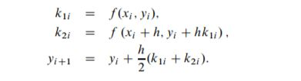

* **def** runge_kutta(x,y,h):

**for** i **in** range(1,len(x)):

k1=f(x[i-1],y[i-1])

k2=f(x[i-1]+h/2,y[i-1]+(h/2)*k1)

k3=f(x[i-1]+h/2,y[i-1]+(h/2)*k2)

k4=f(x[i-1] +h,y[i-1]+h*k3)

y[i]=y[i-1]+(h/6)*(k1+2*k2+2*k3+k4)

This function uses The Runge-Kutta method to solve f, the original task. For every x from 0 to X we find y, using this formula:

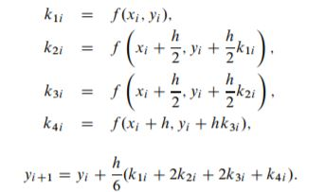

4. Graphs

Graph for the exact solution (how other solutions are supposed to look like):

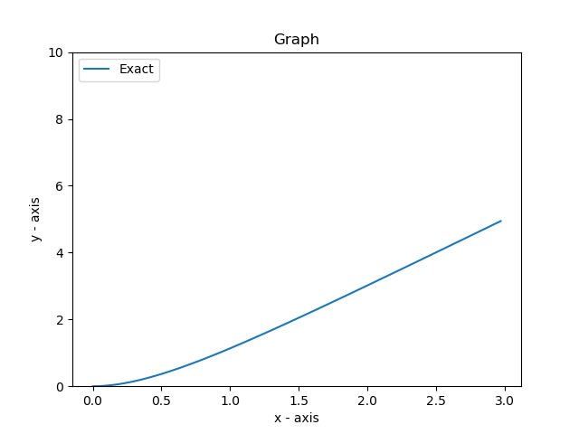

Graph for the Euler method:

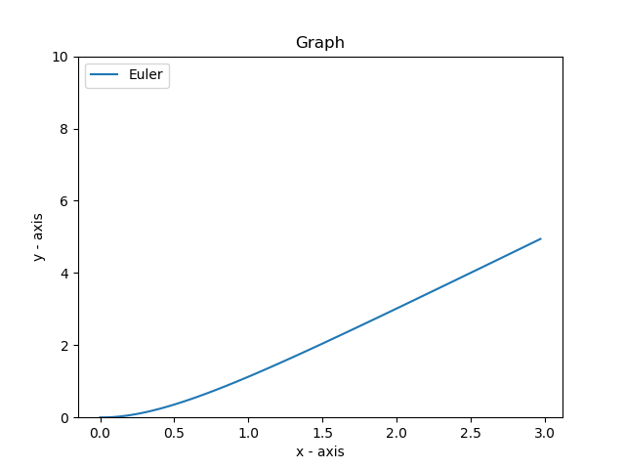

Graph for the Improved Euler method:

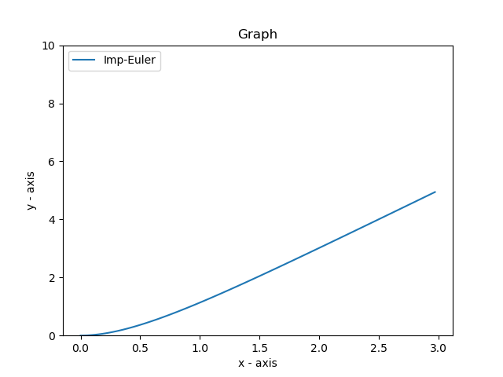

Graph for the The Runge-Kutta method:

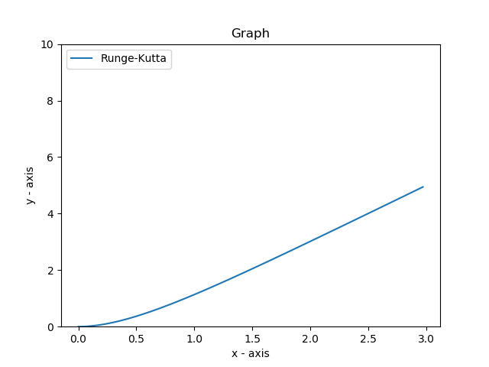

Since they look similar, I would like to show how they look when i put them next to each other:

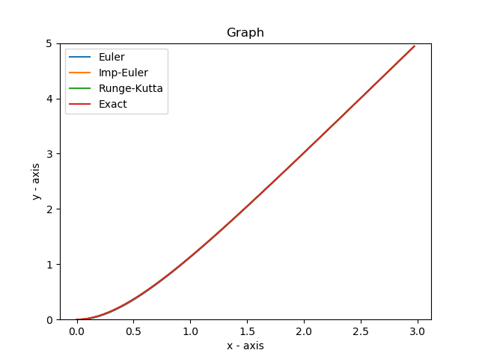

But the difference between graphs is more obvious if I change limits

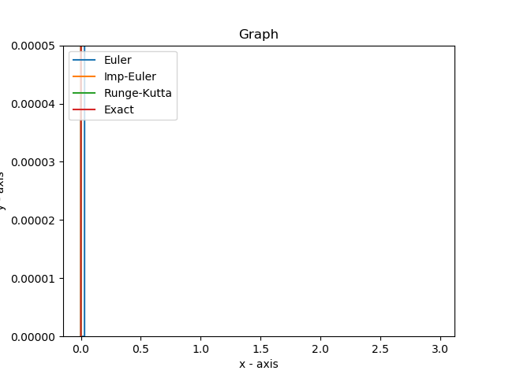

And the Error graph

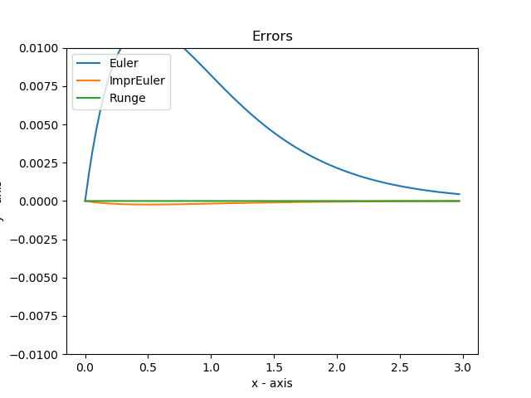

5. Global error.

For finding the best method, we can take a look at the global error:

